DIS-AM,C-Taino-Axe, Handled-and Petuloid Celts-Ceremonial

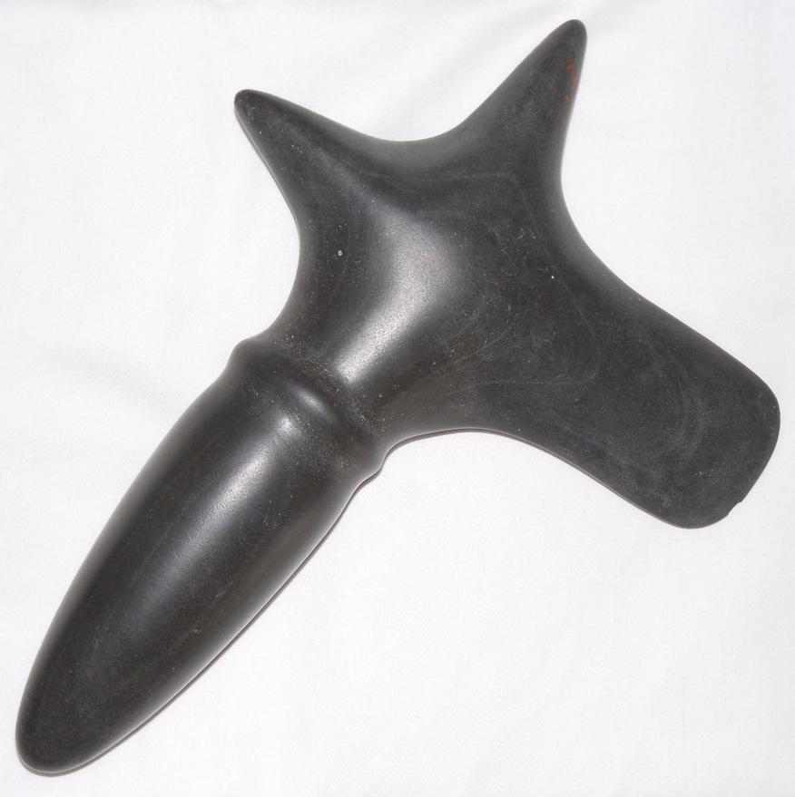 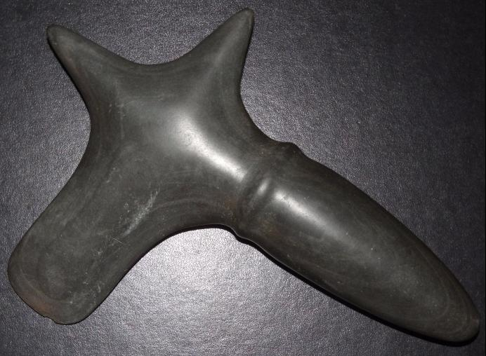

Fig. 1. Greenstone Handled Axe from the Dominican Republic. Ca. 9 in. long.

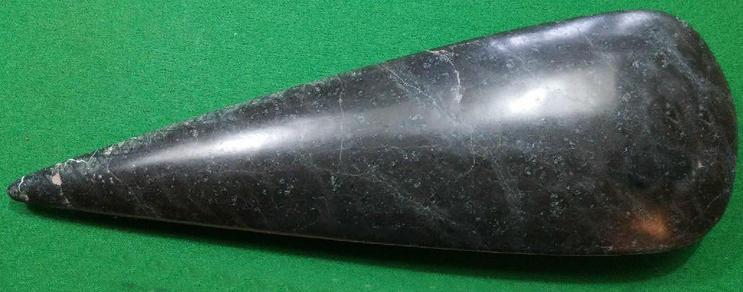

Fig. 2. Greenstone petaloid celt, ca. 15 in. long. Tip Broken off and professionally repaired, From the Dominican Republic.

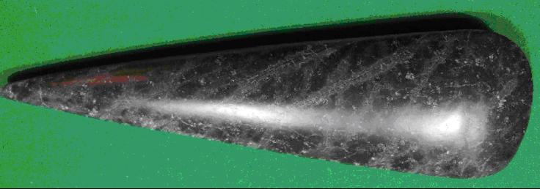

Fig. 3. Taino ceremonial petaloid celt, ca. 12 3/16 in long. From the Dominican Republic.

Greenstone (crystallized mudstone) axes with handles and petaloid celts were produced on St. Martin from indigenous greenstone, which was worked into tools on the Hope Estate sites. These sites have extensive lithic debris including flakes, pre-forms and nodules suitable for trading (De Waal 1999; Haviser 1999; Knippenberg 1999). Finished handled axes and petaloid celts were distributed to settlements from Guadeloupe (Morel site) throughout the northern Lesser Antilles (Hofman et al., 2007: 248-249) to the Puerto Rico sites of La Hueca, Sorcé and Punta Candelero and to eastern Hispaniola (Dominican Republic) (Knippenberg 2004, 2006; Rodríguez Ramos 2001) where the present greenstone examples of a handled axe and two petuloid celts were found (Figs. 1-3) and to the Bahamas where a very similar celt was found (Goggin 1939, see Fig. 4. below). Goggin noted that the nearest source of greenstone was on the Island of Cuba but we have no information about this as being the source for the petaloid celts found on Andros Island or elsewhere in the Bahamas.

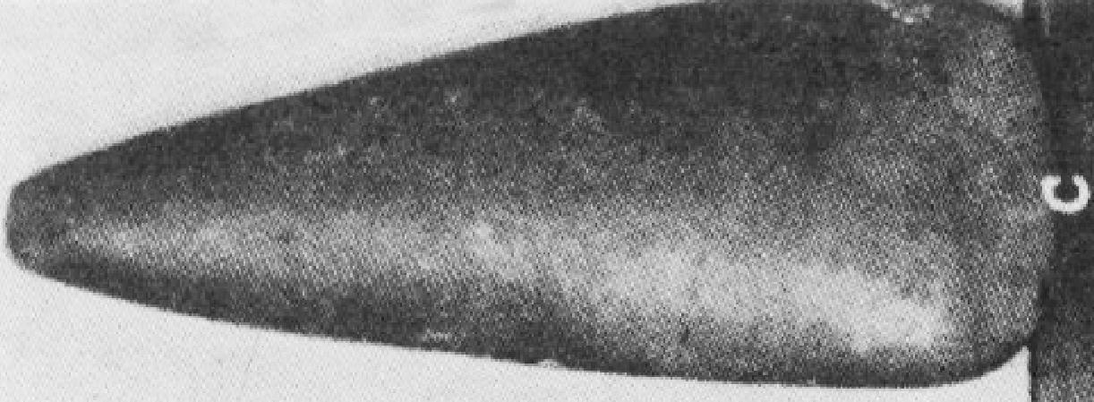

Fig. 4. Taino ceremonial petaloid celt. Ca. 6.5 in long. From the Bahamas, Andros Island, Mangrove Cay. After Goggin 1939, Plate III, Fig. 3c.

These highly polished artifacts were used for ceremonial purposes, as none have marks of use-wear. Since they were large, some, like these examples, being over a foot in length, were presumably intended for élite consumption. They may have ritual significance as a handled axe or celt was used to cut mother tortoise, the progenitrix of humanity, from Deminán’s back. The distribution of highly polished handled axes and celts extends from Trinidad to the Bahamas (Goggin 1939; Sears and Sullivan 1978: 17), suggesting a sophisticated system of trade and exchange of élite ceremonial objects among caciques in efforts to establish alliances or exchange of such objects as means of currency (Roberts 2014: 163). T. A. Joyce (1907: 418) has this description of one of these greenstone handled axes: “Finally, there is the beautiful specimen of stone carving shown on Plate LIV, 8, consisting of an entire axe and haft, carved from solid, fine-grained, pale-greenish stone, well polished. The design represents a petaloid celt fixed in a wooden haft which is secured from splitting by a binding above and below the blade. This axe, which is 316 mm. long, was given to the British Museum in 1830 by Mr. P. L. Strachan. All the information which accompanied it is contained in the following words :-‘ A curiously shaped Indian Battle Axe made of a green siliceous stone.’” We may note that this axe was never intended to do *physical* battle.

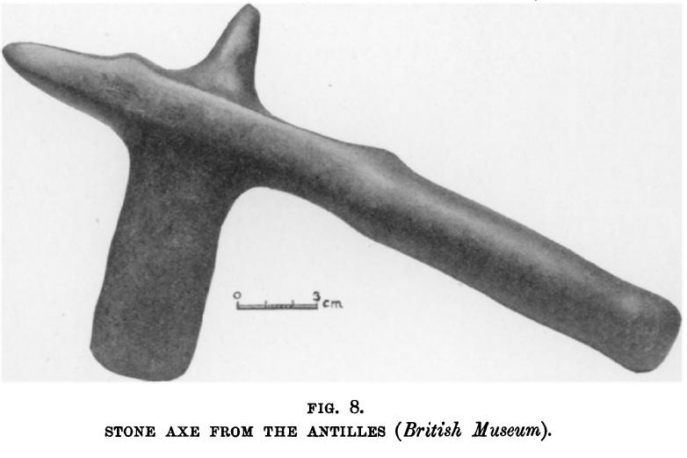

Fig. 5. After Joyce 1907, Plate LIV, Fig. 8, BM 30,5-8, 1).

References:

Goggin, John M. 1939. An Anthropological Reconnaissance of Andros Island, Bahamas, *American Antiquity*, Vol. 5, No. 1 (Jul.), pp. 21-26

Hofman, Corinne L., Alistair J. Bright, Arie Boomert and Sebastiaan Knippenberg. 2007. Island Rhythms: The Web of Social Relationships and Interaction Networks in the Lesser Antillean Archipelago between 400 B.C. and A.D. 1492, *Latin American Antiquity*, Vol. 18, No. 3 (Sep.), pp. 243-268.

Joyce, T. A. 1907. Prehistoric Antiquities from the Antilles, in the British Museum, *The Journal of the Royal Anthropological Institute of Great Britain and Ireland*, Vol. 37 (Jul. - Dec.,), pp. 402-419

Knippenberg, Sebastian. 2004. Distribution and Exchange of Lithic Materials: Three pointers and Axes from St. Martin. In *Late Ceramic Age Societies in the Eastern Caribbean*, edited by Andre Delpuech and Corinne L. Hofman, pp. 121-138. BAR International Series 1273. Oxford: British Archaeological Reports.

Knippenberg, Sebastian. 2006. Stone Artefact Production and Exchange Among the Northern Lesser Antilles. Unpublished Ph.D. dissertation, Faculty of Archaeology, Leiden University, Leiden.

Roberts, Larry. 2014. *Taino Sculpture: art of the gods* (Micanopy, Florida: Signature Book Printing)

Rodríguez Ramos, Reniel. 2001. Lithic Reduction Trajectories at La Hueca and Punta Candelero Sites, Puerto Rico. Unpublished Master's Thesis, Texas A&M University, College Station.

Sears, William H. and Shaun O. Sullivan. 1978. Bahamas Prehistory, *American Antiquity*, Vol. 43, No. 1 (Jan.,), pp. 3-25

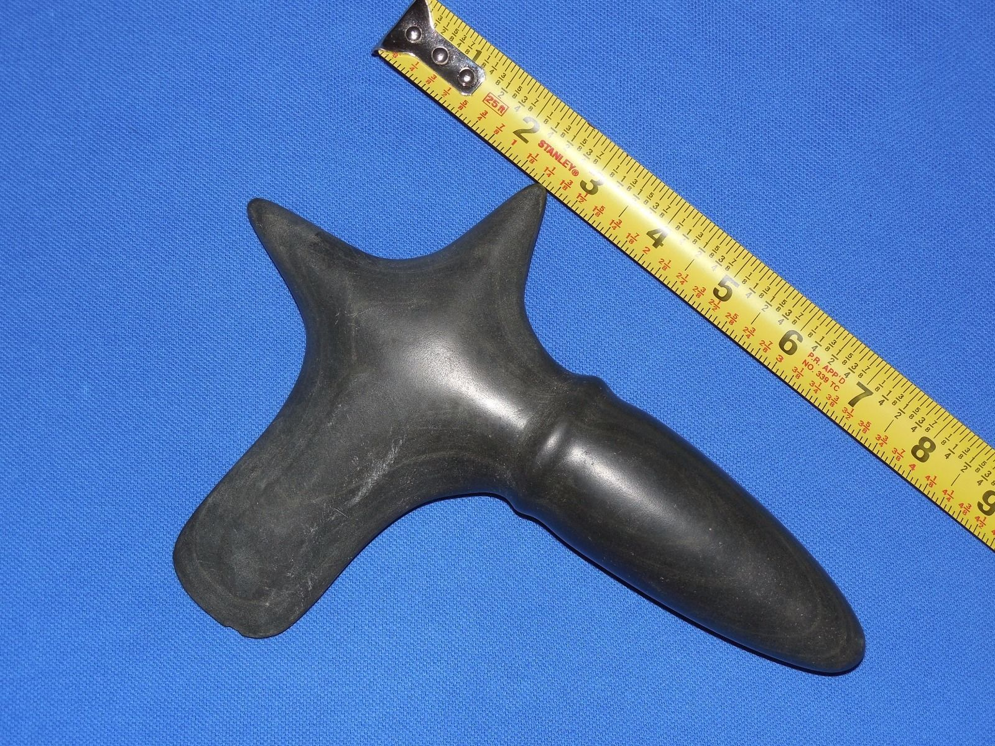

# Order details

## Sales order

Sold by [jeanpier_360](http://myworld.ebay.com/jeanpier_360) ( [94](http://feedback.ebay.com/ws/eBayISAPI.dll?ViewFeedback&userid=jeanpier_360) )

### Delivery package 1 of 1

Estimated delivery Tuesday, Dec 22, 2015 - Saturday, Dec 26, 2015

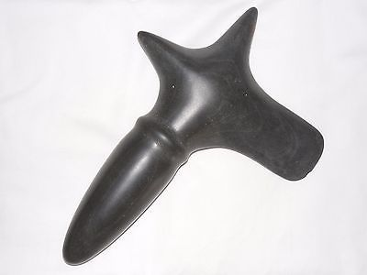

#### [TAINO PRE- COLUMBIAN STONE AXE](http://www.ebay.com/itm/262188331717)

|  |  |
| --- | --- |
| Item price | $299.00 |
| Quantity | 1 |
| Item number | 262188331717 |
| Shipping service | USPS Priority Mail |